1. ➢ Nernst equation- derivation, explanation, importance
2. ➢ Measurement of EMF
3. ➢ Primary and Secondary batteries differences.
4. ➢ Advantages of using fuel cells over traditional batteries.
5. ➢ Construction, working, and applications of SHE with suitable examples.
6. ➢ Electrochemical series- definition, explanation and applications/ uses.
7. ➢ Concentration cells- working principle.
8. ➢ Hydrogen-oxygen fuel cell- working, applications.
9. ➢ methanol-oxygen fuel cell- working, applications.
10. ➢ Lead acid battery- working, reactions, applications.
11. ➢ Nickel-Metal Hydride (NiMH) cells- working, reactions, applications.
12. ➢ Working and applications of Li-ion batteries.
13. ➢ Construction and working of calomel electrodes with an example.
14. ➢ Determination of pH of a given unknown sample.
15. ➢ Pitting corrosion- causes and mechanism.
16. ➢ Factors influencing rate of corrosion.
17. ➢ Wet theory(Electro chemical corr) of corrosion- mechanisms and effects on materials.
18. ➢ Sacrificial anodic method
19. ➢ Impressed current cathode method
20. ➢ Theories of chemical and electrochemical corrosion
21. ➢ Cathodic protection works and illustrate the impressed current method- reactions.
22. ➢ Electroplating process.
23. ➢ Differences between cathodic coatings and anodic coatings.
24. ➢ Chemical theory of corrosion and its types with suitable examples.
25. ➢ Galvanic corrosion and its mechanism
26. ➢ Differential aeration corrosion mechanism with suitable examples.

Answers:

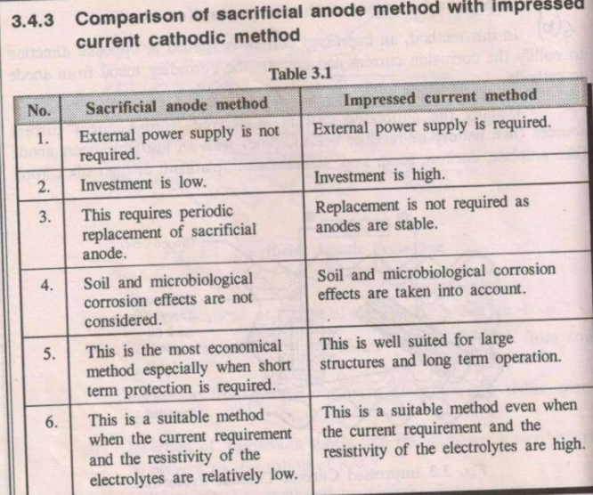

1)

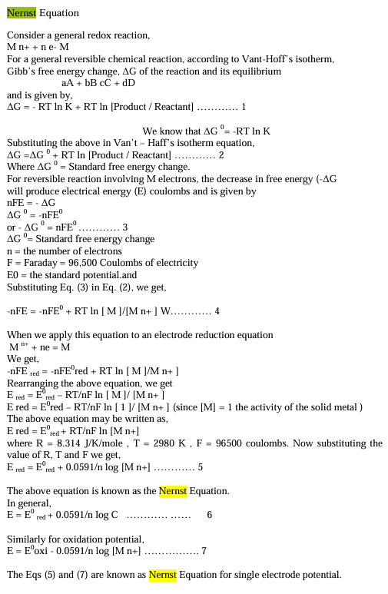

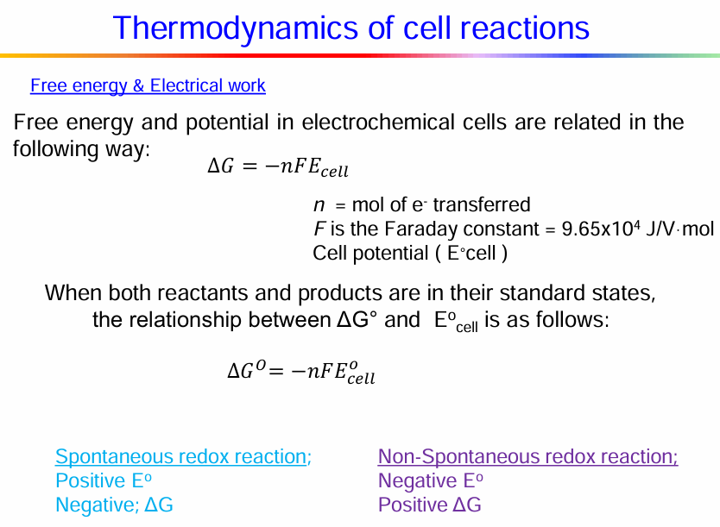

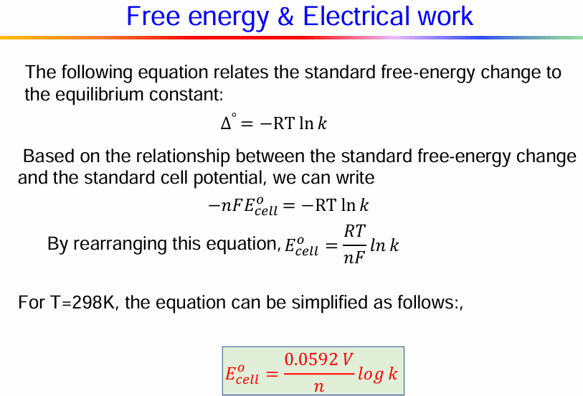

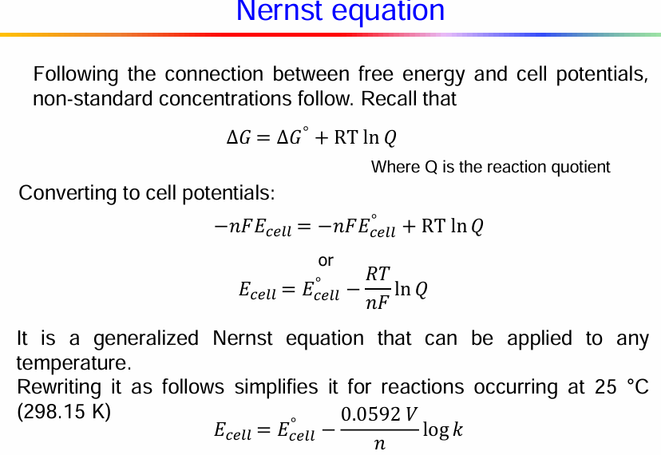

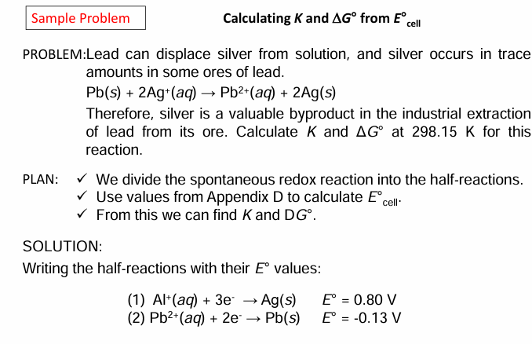

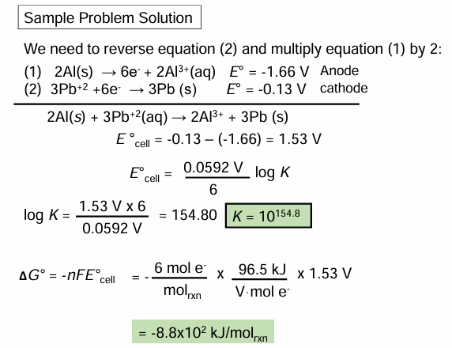

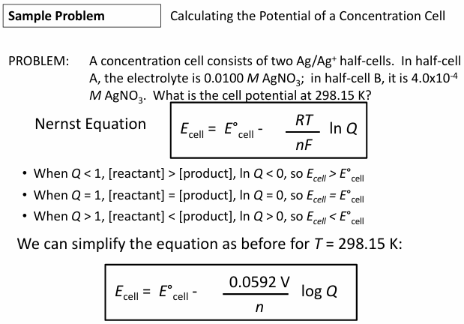



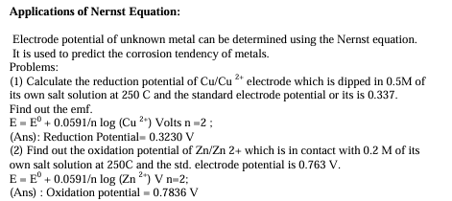



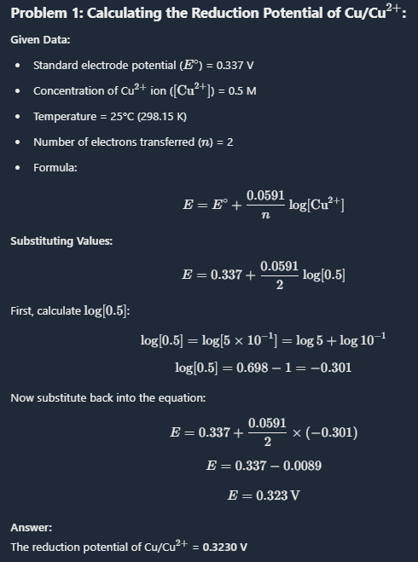

2)

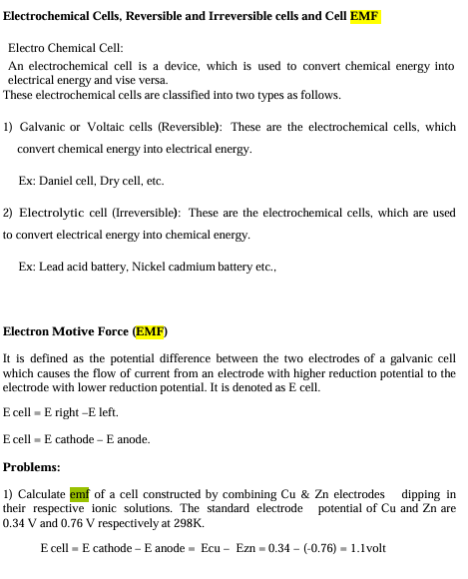

Electromotive force (EMF) can be measured in a few ways:

* **Use a voltmeter**: Measure the voltage across the cell
* **Use an ammeter**: Measure the current in the circuit
* **Use a potentiometer**: A preferred method for measuring a cell's EMF
* **Connect to a circuit**: Connect the battery to a circuit with a resistor, voltmeter, and ammeter. The EMF is the sum of the voltage differences across the resistor and the battery.

EMF is the energy transferred to an electric circuit per unit of electric charge. It is measured in volts.

3)

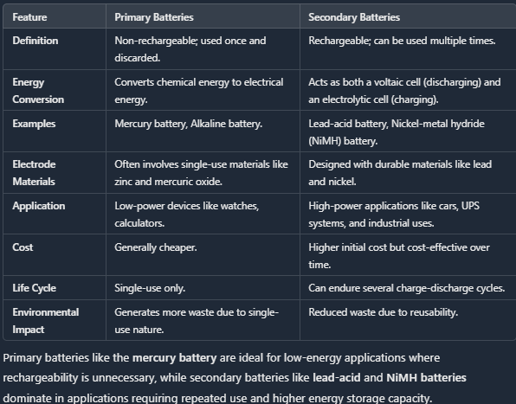

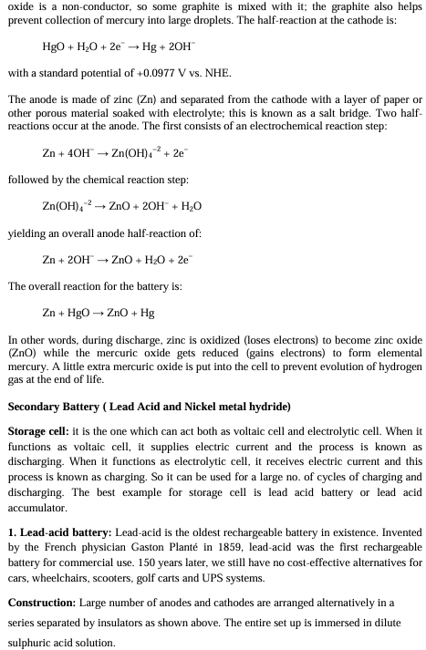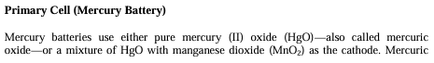

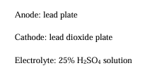

4)

Fuel Cell vs. Battery

• Battery; Energy storage device

– Reactant chemicals already in device

– Once Chemicals used up; discard (unless rechargeable)

• Fuel Cell; Energy conversion device

– Won’t work unless reactants supplied

– Reactants continuously supplied; products continuously removed

Fuel cells have several advantages over traditional batteries, including:

* **Refueling time**: Fuel cells can be refueled in minutes, while batteries can take hours to recharge.
* **Temperature tolerance**: Fuel cells are less sensitive to cold temperatures than batteries.
* **Energy density**: Fuel cells have a higher energy density by weight than batteries.
* **Efficiency**: Fuel cells are often more efficient than traditional batteries.
* **Reliability**: Fuel cells are a dependable energy source because hydrogen stored as a gas or liquid remains ready for use.
* **Environmental impact**: Fuel cells produce minimal emissions, only water vapor and heat.
* **Noise pollution**: Fuel cells do not generate excessive noise.
* **Renewable**: Hydrogen is the most abundant element on earth.

Fuel cells convert an energy source, such as hydrogen, propane, diesel, or natural gas, into electrical energy. Batteries, on the other hand, store energy.

1. **Higher Energy Efficiency**: Fuel cells convert chemical energy directly into electrical energy, which can result in higher efficiency compared to batteries that involve multiple energy conversion steps.
2. **Longer Runtime**: Fuel cells can operate continuously as long as fuel (like hydrogen) is supplied, whereas batteries have a limited capacity and need recharging once depleted.
3. **Lower Emissions**: Fuel cells typically produce fewer emissions than conventional batteries, especially when using hydrogen, which only emits water vapor as a byproduct.

5)

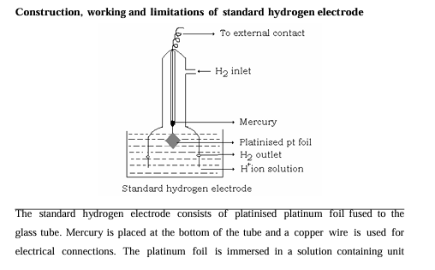

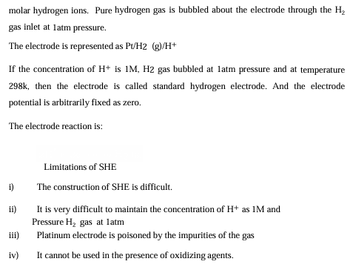

Applications of SHE include its use in determining standard electrode potentials for various half-reactions, providing a basis for electrochemical measuring instruments, and facilitating pH measurements in analytical chemistry. For example, when considering the cell potential in galvanic cells, the SHE is frequently used as the reference point.

6)

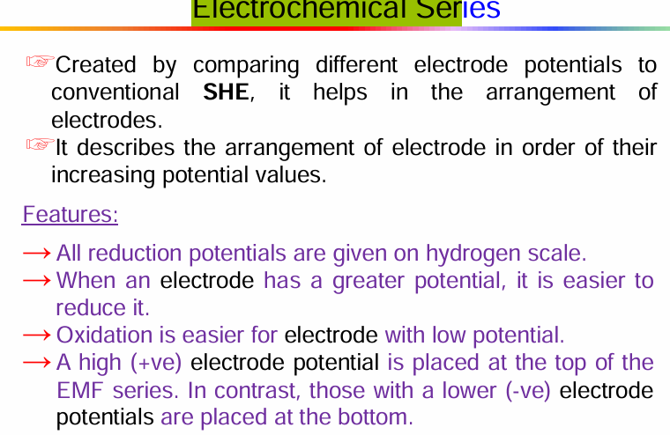

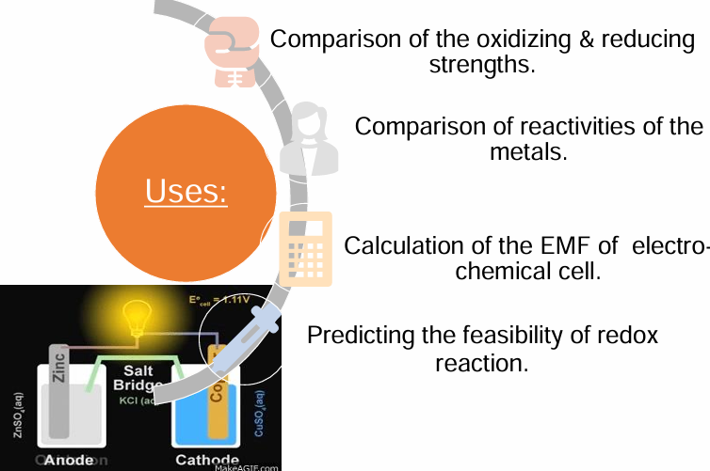

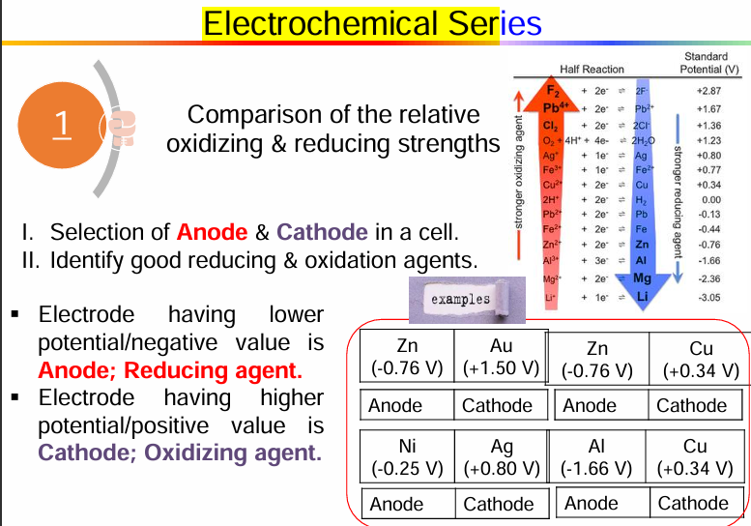

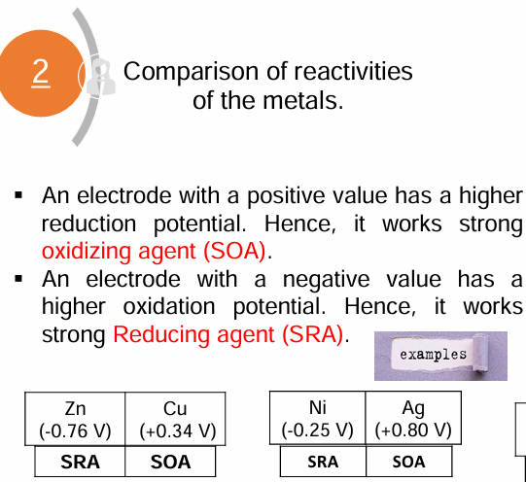

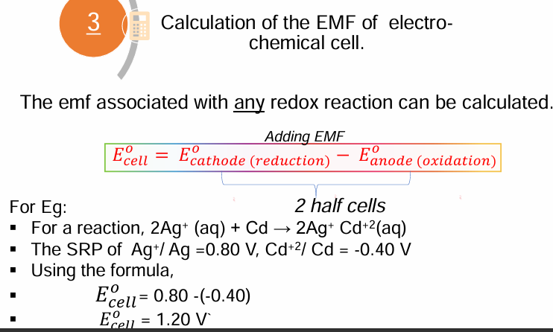

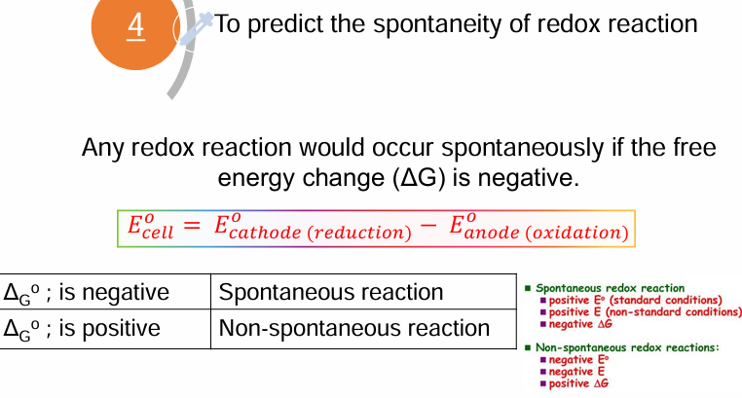

7)

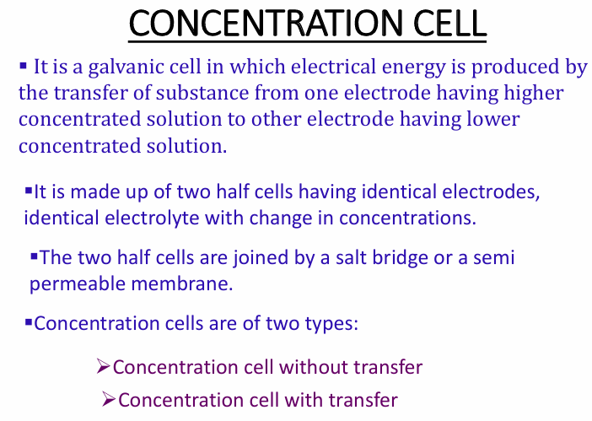

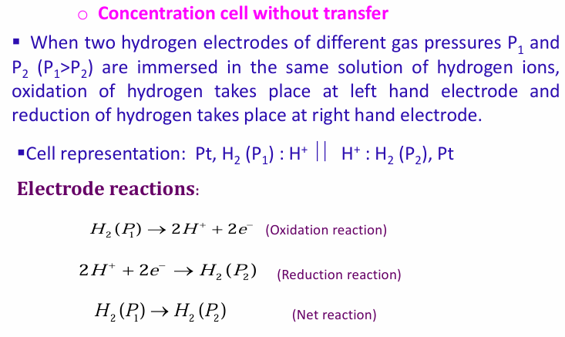

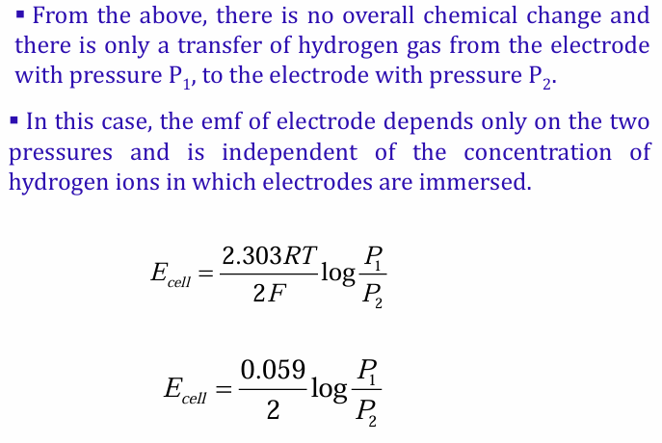

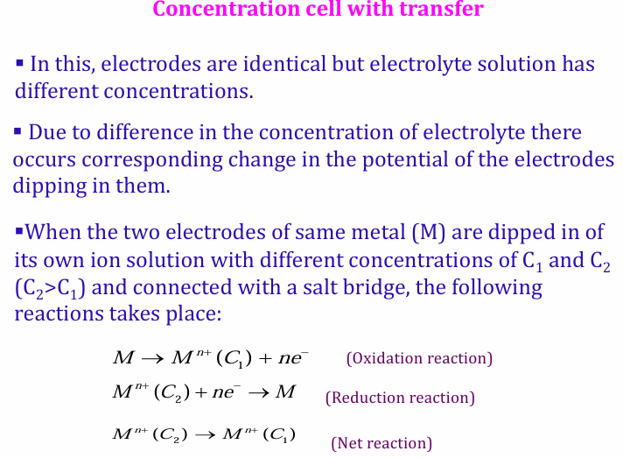

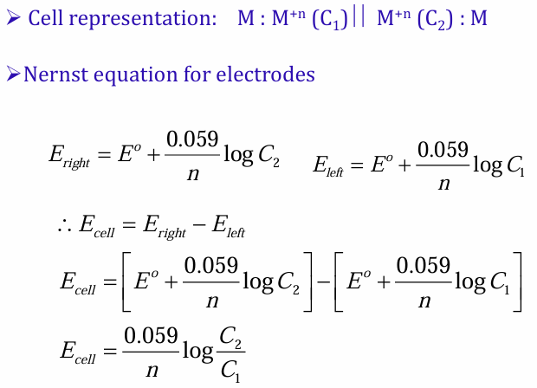

8)

εElectrode is made of graphite impregnated with fine powder

of Pt or an alloy of Pb with Ag or Ni

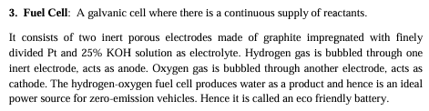

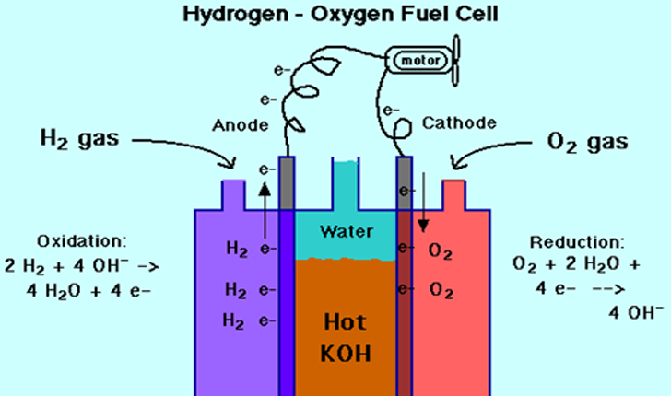

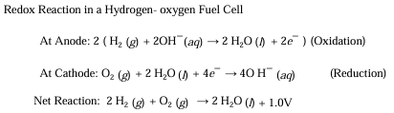

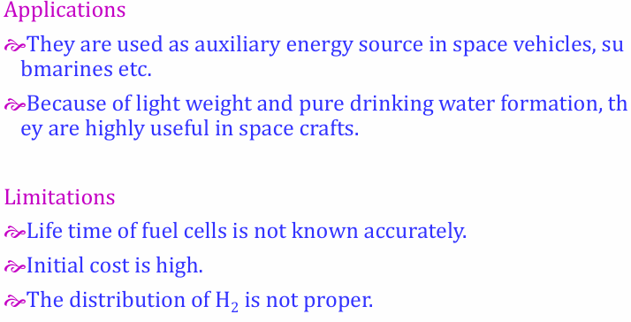

9)

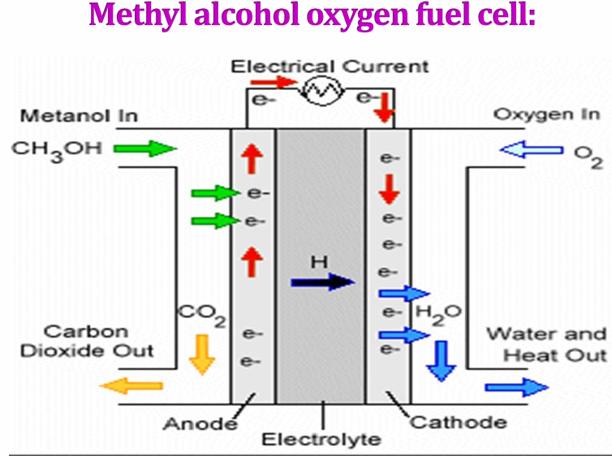

Methyl alcohol fuel cell  
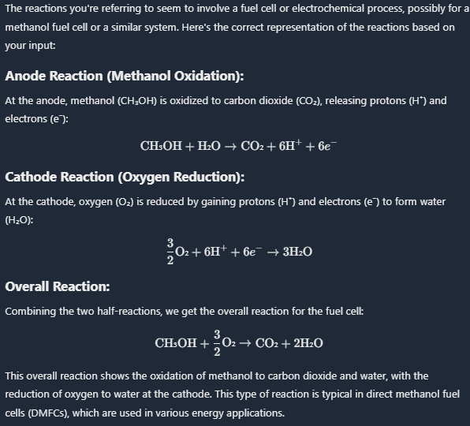  
Limitations

εMethanol toxic and flammable

εProduce limited power

Advantages

εStorage of methanol is easy

10)

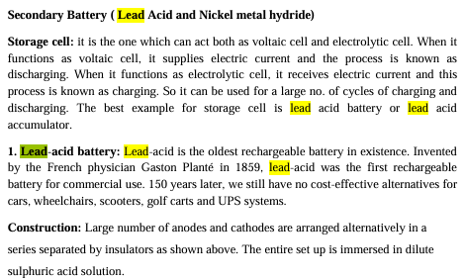

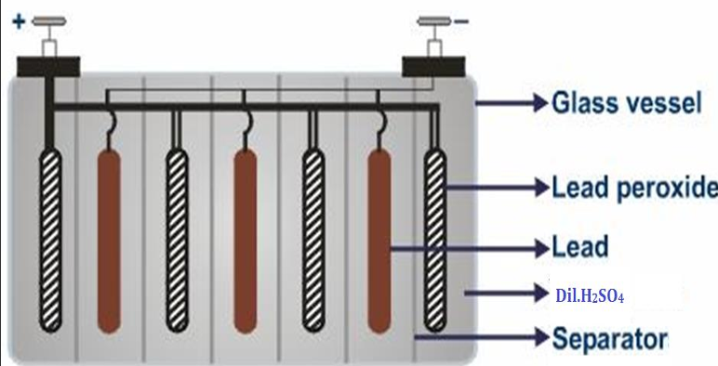

εIt can acts as voltaic cell and electrolytic cell.

εEach cell has voltage 2 volts.

εMany such cells connected in series develop total potential.

εA 12V battery has six cells

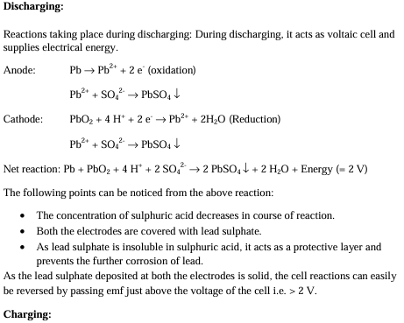



11)

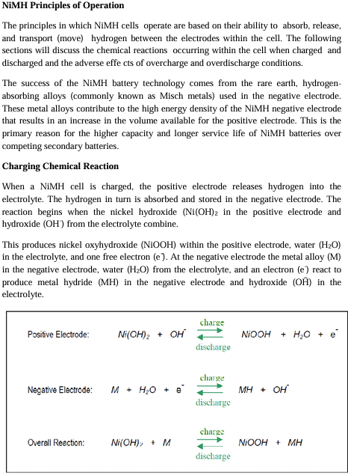

NiMH cells are used in many applications, including:

* **Consumer electronics**: Digital cameras, remote controls, cordless phones, and more
* **Electric vehicles**: NiMH cells were used in first-generation electric vehicles
* **Medical devices**: Infusion pumps and portable diagnostic devices
* **Power tools**: Drills, saws, and screwdrivers
* **Solar energy storage**: NiMH batteries store electrical energy generated during the day for later use

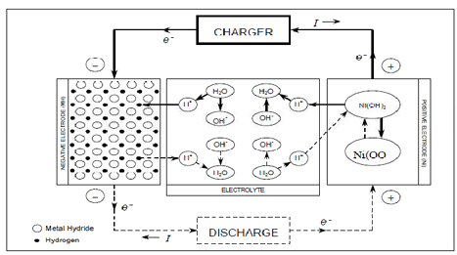

12)

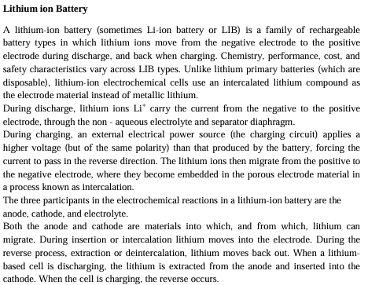

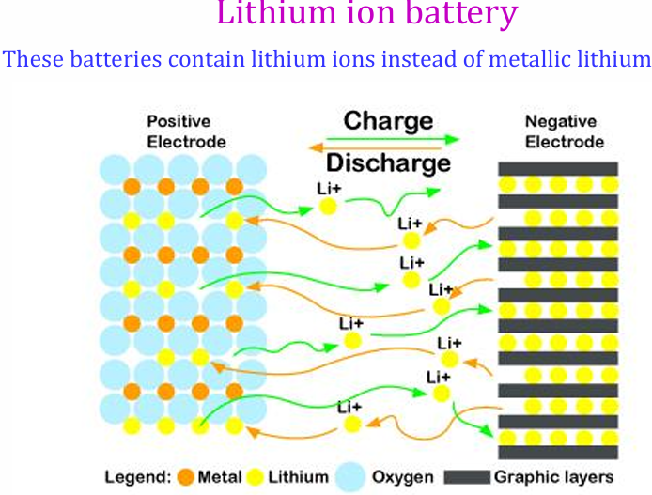

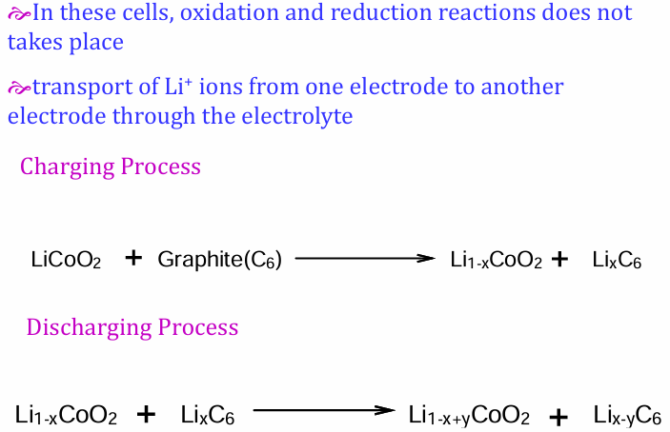

Example uses:• Telecommunication ; PV Generation ;• Wind Generator

• Power Tools ;E-bike ;• Street Lighting System ;• UPS and Backup System

13)

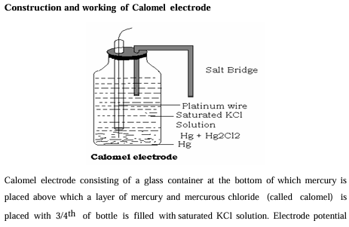

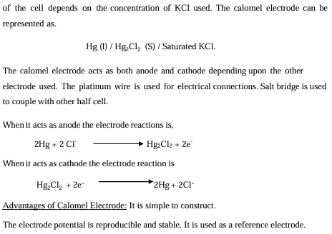

14)

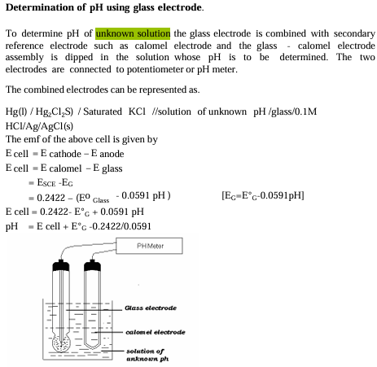

15)

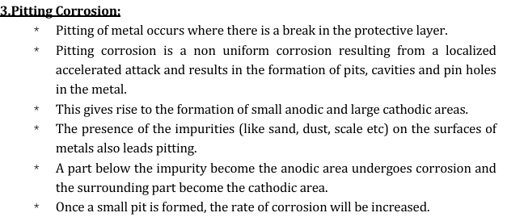

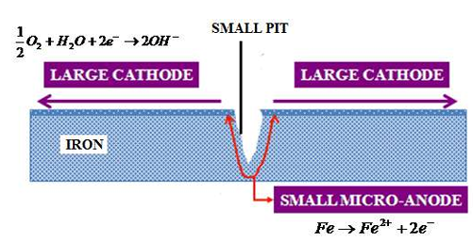

Causes:

* Damage/cracking of protective film over the metal.
* Materials having poor surface finish.
* Presence of impurities on metal surfaces (sand & dust).
* Stagnant water conditions favor pitting (low velocity)
* Chemical attack(Chloride damages the protective oxide layer).

**Ways to prevent pitting corrosion :**

→Selection of appropriate material;

→Controlling oxygen level

→Providing stirring of the electrolyte;

→Control of the electrolyte composition (PH, chloride ions);

→Corrosion inhibitors;

→Anodic & Cathodic protection;

→Corrosion protection coatings

16)

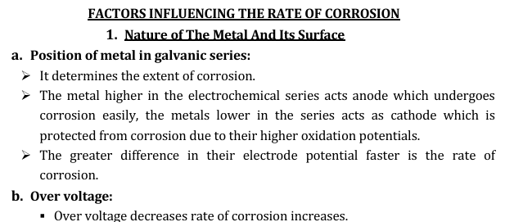

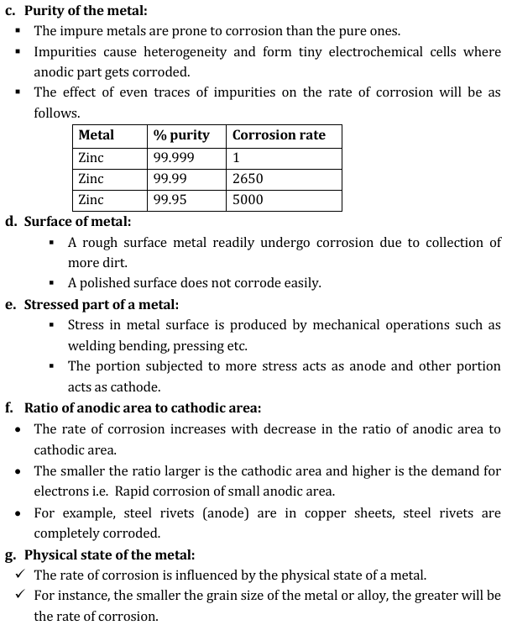

17)

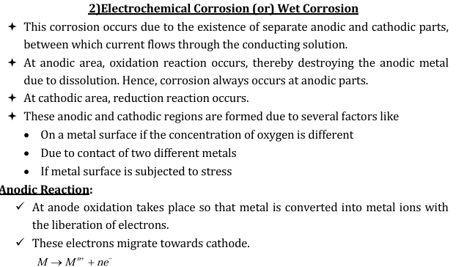

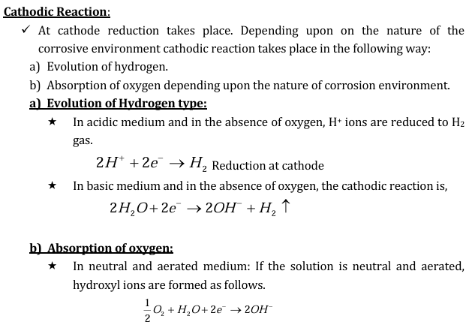

18)

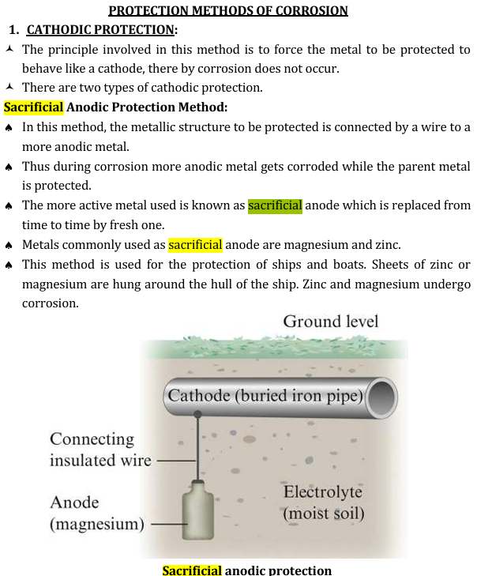

Applications: Important applications of sacrificial anodic

method include protection of buried lines, underground cables, marine

structures etc

19)

CATHODIC PROTECTION :

♥ The principle involved in this method is to force the metal to be protected to behave like a cathode, there by corrosion does not occur.

♥ There are two types of cathodic protection.

a)Sacrificial Anodic Protection Method:

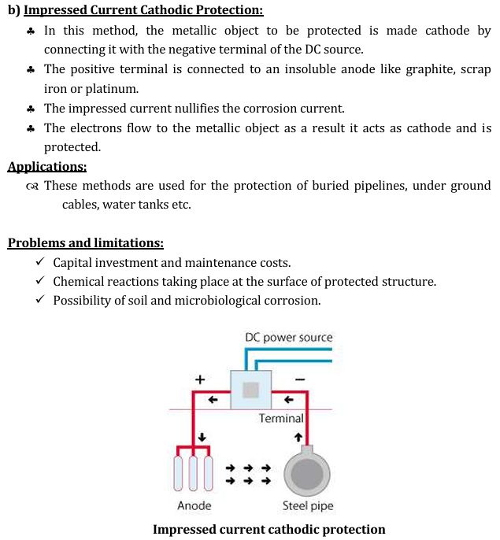

Applications:

▪ Submarines are protected against corrosion by connecting the negative terminal of DC generators to the surface.

▪ Water tanks, buried oil or water pipelines, transmission line towers are protected by this method.

20)

The basic principles of electrochemical corrosion are:

* **Electrochemical cell**

Electrochemical corrosion requires an anode, a cathode, an electrolyte, and a flow of electricity between the anode and the cathode.

* **Anodic corrosion**

The anode corrodes preferentially over the cathode.

* **Corrosion rate**

The smaller the anode area relative to the cathode area, the faster the corrosion rate.

* **Corrosion rate calculation**

Corrosion rate can be calculated using Faraday's law, which expresses weight loss as a function of the metal's consumption rate, the current flow, and the time the metal is exposed to the current.

* **Electrochemical impedance spectroscopy (EIS)**

EIS is a method used to study corrosion systems. EIS can use small amplitude signals without significantly disturbing the properties being measured.

* **Polarization curves**

Polarization curves can be used to study the electrochemical corrosion behavior of metals and alloys.

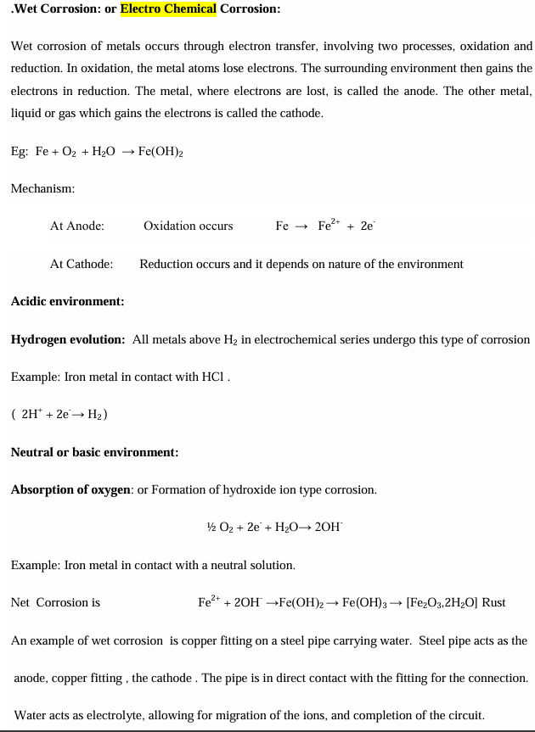

22)

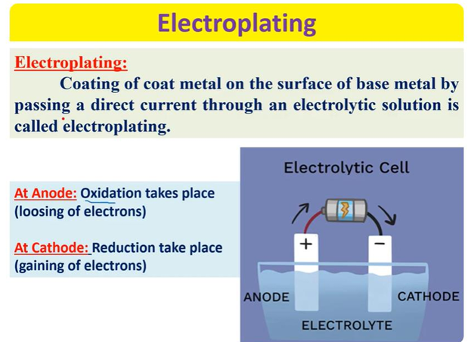

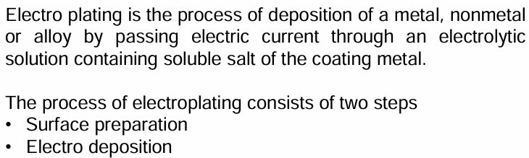

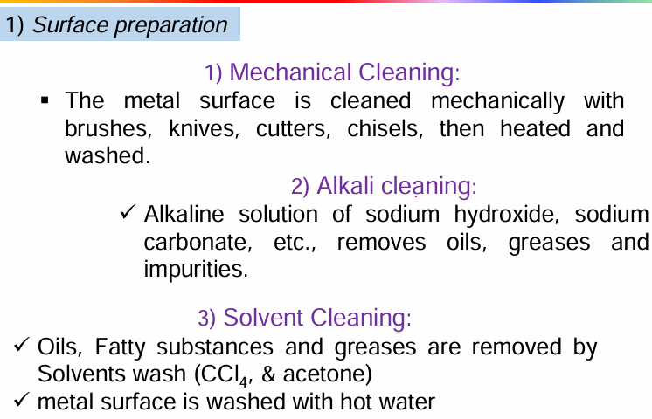

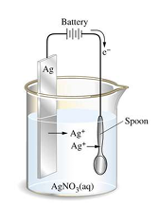

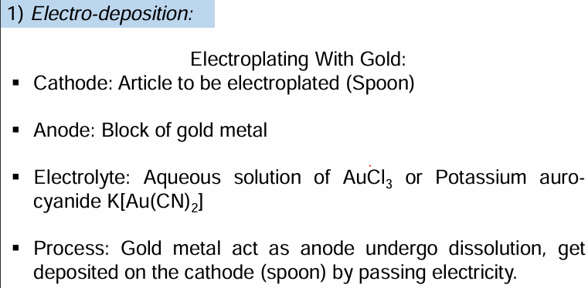

23)

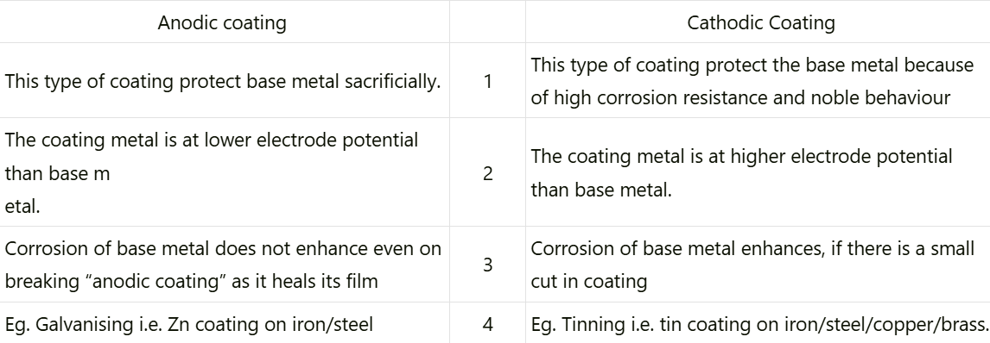

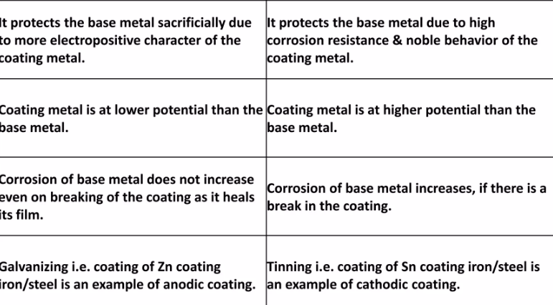

24)

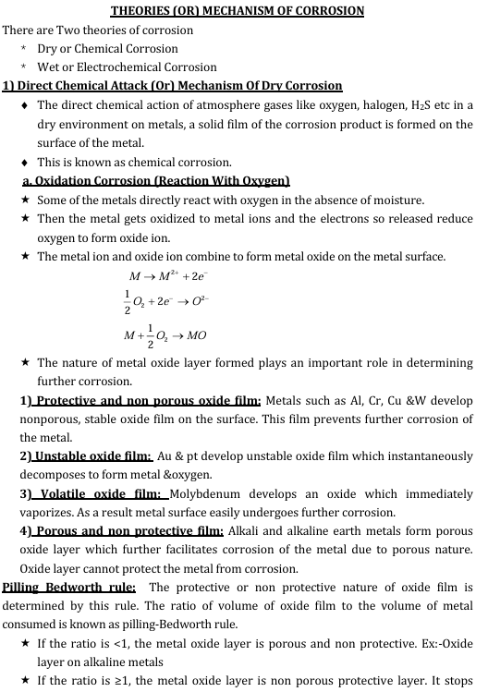

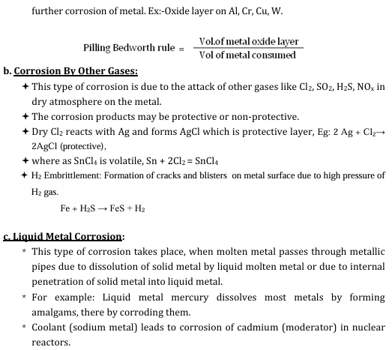

25)

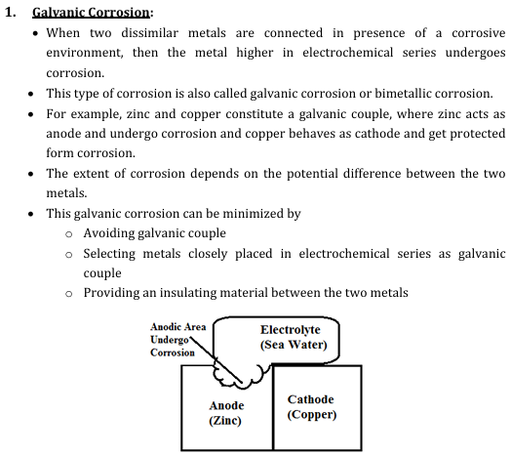

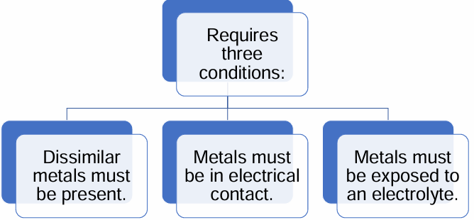

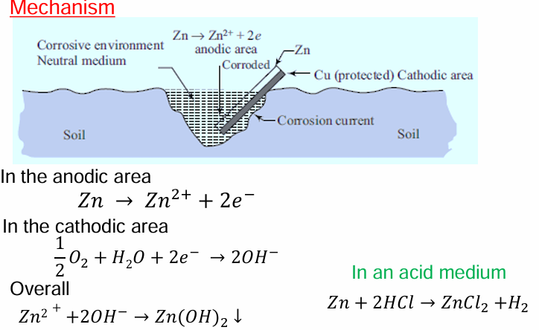

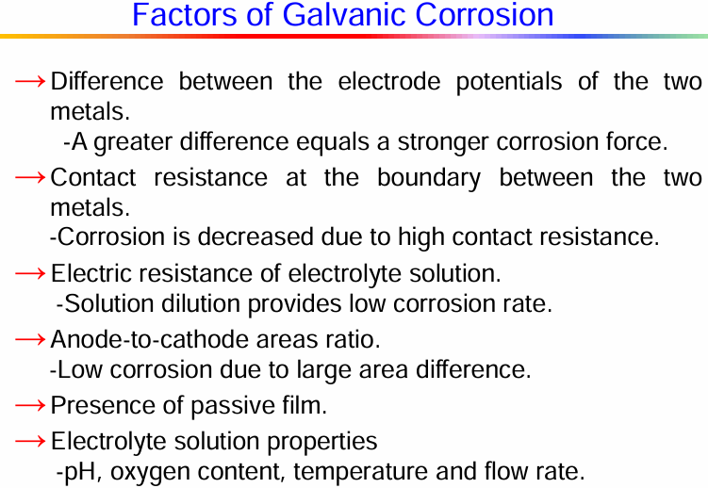

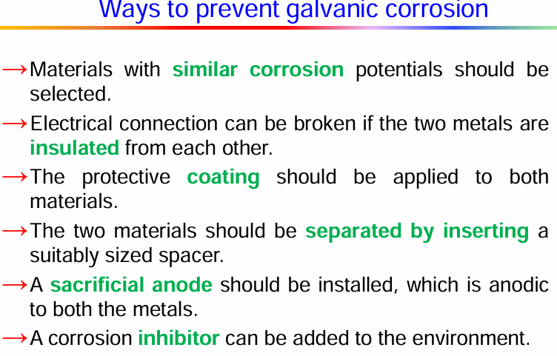

26)

